**B.M.S. College of Engineering**

**(Autonomous Institution affiliated to VTU, Belagavi)**

Department of Computer Science and Engineering



**LAB REPORT**

**OBJECT ORIENTED JAVA PROGRAMMING**

**23CS3PCOOJ**

(December 2023-March 2024)

**B.M.S. College of Engineering**

**Department of Computer Science and Engineering**



**Laboratory Certificate**

This is to certify that Supreeth A R has satisfactorily completed the course of Experiments in Practical OBJECT ORIENTED JAVA PROGRAMMING prescribed by the Department during the odd semester 2023-24.

Name of the Candidate: Supreeth A R

USN No.: 2023BMS02528 Semester: III Section: F

MAX MARKS OBTAINED

10

MARKS IN WORDS:

Signature of the staff in-charge Head of the Department

Date:

1.Write a Java program to create a class Grocery that has the variables c_name and c_phone. Create a method to accept 3 parameters to specify quantity of dal, quantity of pulses an quantity of sugar. The method to return the total price. Display the name, ph_no and total bill of 3 customers.

class groceryinfo{

String c_name;

String c_ph;

double total;

groceryinfo(String c_name,String c_ph)

{

this.c_name=c_name;

this.c_ph=c_ph;

}

void calc(double q_dal,double q_pulses,double q_sugar)

{

total=q_dal*100+q_pulses*80+q_sugar*50;

}

void display()

{

System.out.println("Name"+" "+"Phonenumber"+" "+"Total");

System.out.println(c_name+" "+c_ph+" "+total);

System.out.println();

}

}

class grocery

{

public static void main(String[] args)

{

groceryinfo g1=new groceryinfo("Rama","123");

groceryinfo g2=new groceryinfo("Shama","456");

groceryinfo g3=new groceryinfo("Bhama","789");

g1.calc(2,2,1);

g1.display();

g2.calc(3,5,2);

g2.display();

g3.calc(1,1,0.5);

g3.display();

}

}

OUTPUT:

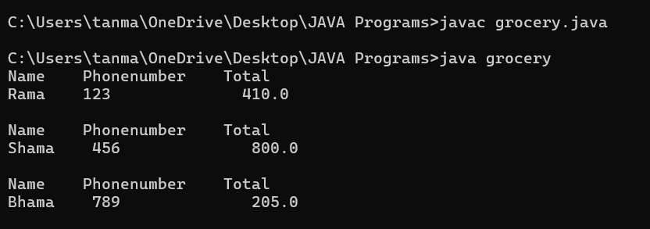

2.Write a program to overload the method print that prints sum of n natural numbers when one variable is passed, and prints the prime numbers in a given range when 2 parameters are passed.

class overloaddemo

{

void print(int n) {

int sum = 0;

for(int i=1; i<=n;i++) {

sum = sum+i;

}

System.out.println("Sum of "+n+" natural numbers is "+sum);

}

void print(int m, int n) {

System.out.println("Prime numbers in the range are ");

for(int i=m;i<=n;i++) {

int flag=0;

for(int j=2;j<=i/2;j++) {

if(i%j == 0) {

flag = 1;

break;

}

}

if(flag==0)

System.out.println(i);

}

}

}

class overload

{

public static void main(String[] args)

{

overloaddemo o = new overloaddemo();

o.print(5);

o.print(7,13);

}

}

OUTPUT:

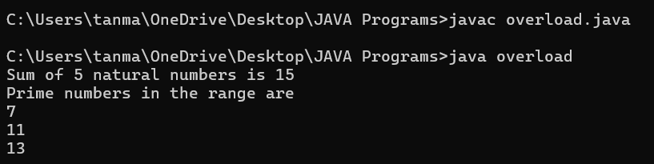

3.Develop a Java program that prints all real solutions to the quadratic equation ax2+bx+c= 0. Read in a, b, c and use the quadratic formula. If the discriminate b2-4ac is negative,display a message stating that there are no real solutions.

import java.util.Scanner;

class Quad{

int a, b, c;

double root1, root2, d;

Scanner s = new Scanner(System.in);

void input()

{

System.out.println("Quadratic equation is in the form : ax^2 + bx + c");

System.out.print("Enter a:");

a = s.nextInt();

System.out.print("Enter b:");

b = s.nextInt();

System.out.print("Enter c:");

c = s.nextInt();

}

void discriminant() {

d= (b*b)-(4*a*c);

}

void calculateRoots() {

if(d>0)

{

System.out.println("Roots are real and unequal");

root1 = ( - b + Math.sqrt(d))/(2*a);

root2 = (-b - Math.sqrt(d))/(2*a);

System.out.println("First root is:"+root1);

System.out.println("Second root is:"+root2);

}

else if(d == 0)

{

System.out.println("Roots are real and equal");

root1 = (-b+Math.sqrt(d))/(2*a);

System.out.println("Root:"+root1);

}

else

{

System.out.println("No real solutions. Roots are imaginary");

}

}

}

class Main {

public static void main(String[] args) {

Quad q= new Quad();

q.input();

q.discriminant();

q.calculateRoots();

}

}

OUTPUT:

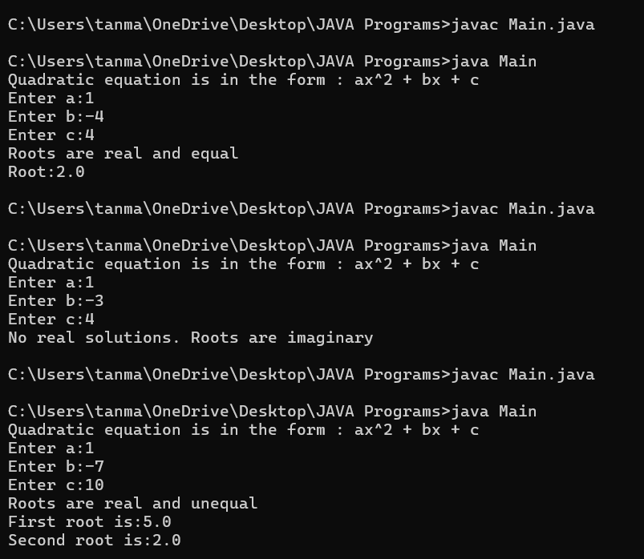

4.Create a class Book which contains four members: name, author, price, numpages.Include a constructor to set the values for the members. Include methods to set and get the details of the objects. Include a toString( ) method that could display the

complete details of the book. Develop a Java program to create n book objects.

import java.util.Scanner;

class Book{

String name;

String author;

int price;

int numpages;

Book(){}

Book(String name,String author,int price,int numpages)

{this.name=name;

this.author=author;

this.price=price;

this.numpages=numpages;

}

public String toString(){

String name,author,price,numpages;

name="Book name:"+this.name+"\n";

author="Author name:"+this.author+"\n";

price="Price:"+this.price+"\n";

numpages="Number of pages:"+this.numpages+"\n";

return name+author+price+numpages;}

}

class Books{

public static void main(String args[])

{Scanner s=new Scanner(System.in);

int n;

String name;

String author;

int price;

int numpages;

System.out.println("\nEnter number of books:");

n=s.nextInt();

Book b[];

b=new Book[n];

for(int i=0;i<n;i++)

{System.out.println("\nBook"+(i+1)+":");

System.out.println("Enter name of the book:");

name=s.next();

System.out.println("Enter author name:");

author=s.next();

System.out.println("Enter price:");

price=s.nextInt();

System.out.println("Enter number of pages:");

numpages=s.nextInt();

b[i]=new Book(name,author,price,numpages);;

}

for(int i=0;i<n;i++)

{System.out.println("\nBook"+(i+1)+"\n"+b[i]);}

}

}

OUTPUT:

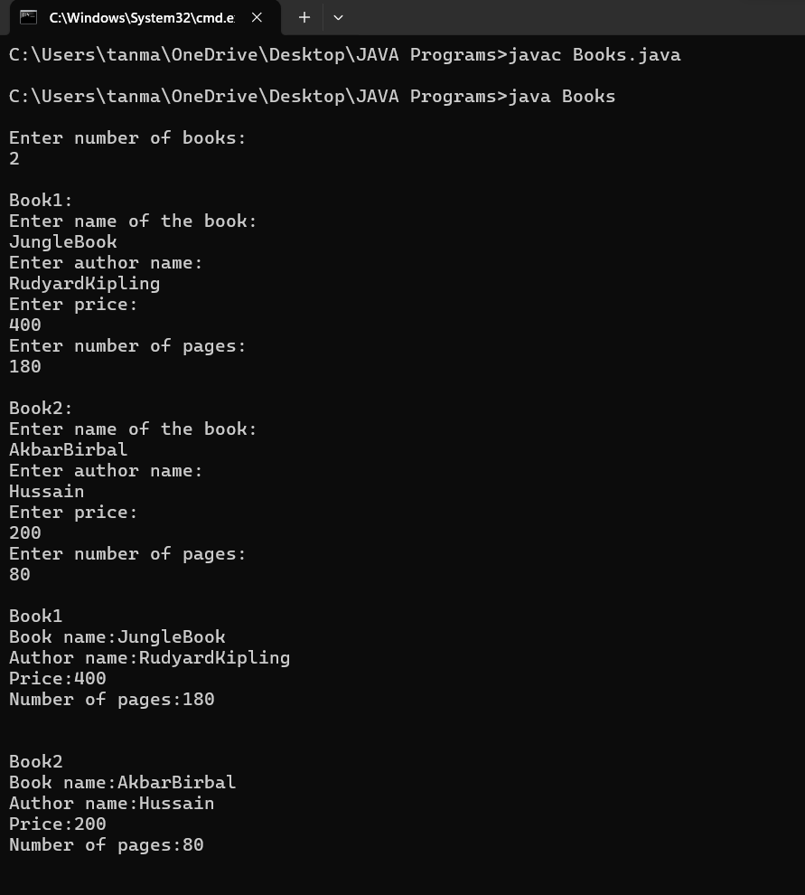

5.Develop a Java program to create a class Student with members usn, name, and an array marks. Include methods to accept and display details and a method to calculate percentage of a student.

import java.util.Scanner;

class studentmem{

String USN;

String Name;

double [] marks=new double[6];

void inputDetails()

{Scanner s=new Scanner(System.in);

System.out.println("Enter USN:");

USN=s.next();

System.out.println("Enter Name:");

Name=s.next();

System.out.println("Enter marks of 6 Subjects");

for(int i=0;i<6;i++)

{System.out.println("Subject"+(i+1)+":");

marks[i]=s.nextDouble();

}}

double calculatePercentage(){

double totalmarks=0;

for(double mark:marks){

totalmarks+=mark;}

return (totalmarks/6);

}

void displayDetails()

{System.out.println("\nStudent Details:");

System.out.println("USN:"+USN);

System.out.println("Name"+Name);

System.out.println("Percentage:"+calculatePercentage()+"%");}

}

public class student{

public static void main(String args[]){

Scanner s=new Scanner(System.in);

System.out.println("Enter number of students:");

int num=s.nextInt();

studentmem [] students=new studentmem[num];

for(int i=0;i<num;i++)

{System.out.println("\nEnter details for Student"+(i+1)+":");

students[i]=new studentmem();

students[i].inputDetails();}

for(studentmem student:students)

{student.displayDetails();}

}}

OUTPUT:

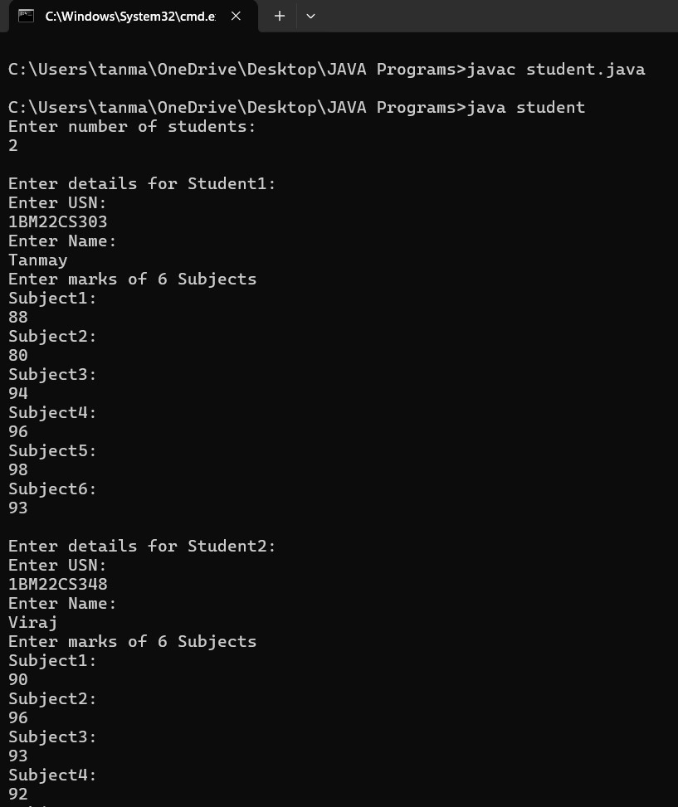

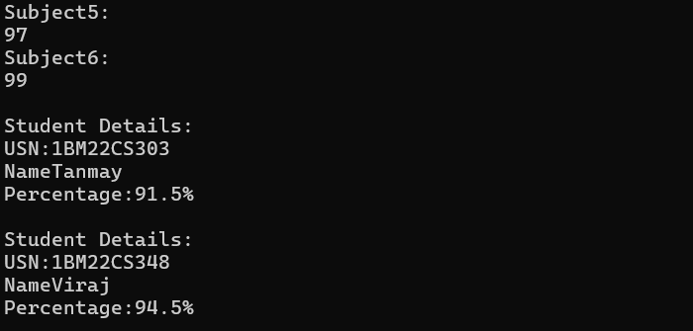

6.Develop a Java program to create an abstract class named Shape that contains two integers and an empty method named printArea( ). Provide three classes named Rectangle, Triangle and Circle such that each one of the classes extends the class

Shape. Each one of the classes contain only the method printArea( ) that prints the area of the given shape.

import java.util.Scanner;

abstract class shape {

int dim1;

int dim2;

shape(int dim1, int dim2) {

this.dim1 = dim1;

this.dim2 = dim2;

}

abstract void printArea();

}

class rectangle extends shape {

rectangle(int length, int breadth) {

super(length, breadth);

}

void printArea() {

double area = dim1 * dim2;

System.out.println("Area of rectangle = " + area);

}

}

class triangle extends shape {

triangle(int height, int base) {

super(height, base);

}

void printArea() {

double area = 0.5 * dim1 * dim2;

System.out.println("Area of triangle = " + area);

}

}

class circle extends shape {

circle(int radius) {

super(radius, 0);

}

void printArea() {

double area = Math.PI * dim1 * dim1;

System.out.println("Area of circle = " + area);

}

}

public class Abstract {

public static void main(String[] args) {

Scanner s = new Scanner(System.in);

System.out.println("Enter the length and breadth of the rectangle");

int l = s.nextInt();

int b = s.nextInt();

System.out.println("Enter base and height of the triangle");

int ba = s.nextInt();

int h = s.nextInt();

System.out.println("Enter the radius of the circle");

int r = s.nextInt();

rectangle re = new rectangle(l, b);

triangle t = new triangle(h, ba);

circle c = new circle(r);

re.printArea();

t.printArea();

c.printArea();

}

}

OUTPUT:

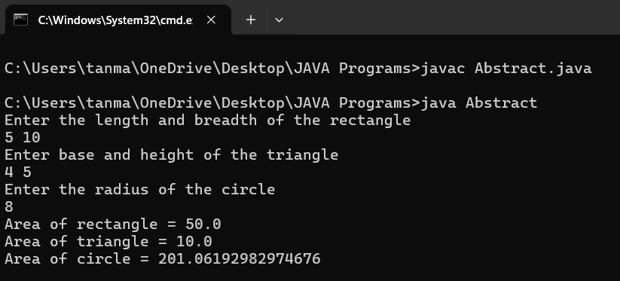

7.Develop a Java program to create a class Bank that maintains two kinds of account for its customers, one called savings account and the other current account. The savings account provides compound interest and withdrawal facilities but no cheque book facility. The current account provides cheque book facility but no interest. Current account holders should also maintain a minimum balance and if the balance falls below this level, a service charge is imposed.

Create a class Account that stores customer name, account number and type of account. From this derive the classes Cur-acct and Sav-acct to make them more specific to their requirements. Include the necessary methods in order to achieve the following

tasks:

a) Accept deposit from customer and update the balance.

b) Display the balance.

c) Compute and deposit interest

d) Permit withdrawal and update the balance

Check for the minimum balance, impose penalty if necessary and update the balance.

OUTPUT:

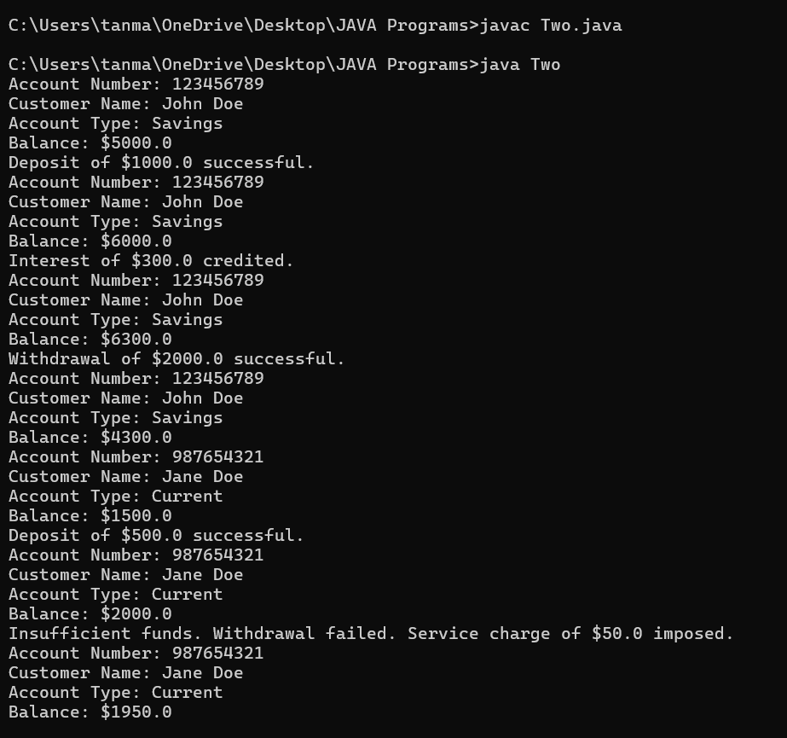

8.Create a package CIE which has two classes- Student and Internals. The class Personal has members like usn, name, sem. The class internals has an array that stores the internal marks scored in five courses of the current semester of the student. Create another package SEE which has the class External which is a derived class of Student. This class has an array that stores the SEE marks scored in five courses of the current

semester of the student. Import the two packages in a file that declares the final marks of n students in all five courses.

package CIE;

public class students {

public String usn;

public String name;

public int sem;

public students(String usn, String name, int sem) {

this.usn = usn;

this.name = name;

this.sem = sem;

}

}

package CIE;

public class internals extends students {

public int[] internalMarks;

public internals(String usn, String name, int sem, int[] internalMarks) {

super(usn, name, sem);

this.internalMarks = internalMarks;

}

}

package SEE;

import CIE.students;

public class externals extends students {

public int[] seeMarks;

public externals(String usn, String name, int sem, int[] seeMarks) {

super(usn, name, sem);

this.seeMarks = seeMarks;

}

}

import java.util.Scanner;

import CIE.internals;

import SEE.externals;

public class packages {

public static void main(String[] args) {

Scanner scanner = new Scanner(System.in);

System.out.print("Enter the number of students: ");

int n = scanner.nextInt();

internals[] cieStudents = new internals[n];

externals[] seeStudents = new externals[n];

for (int i = 0; i < n; i++) {

System.out.println("Enter details for CIE of student " + (i + 1));

System.out.print("USN: ");

String usn = scanner.next();

System.out.print("Name: ");

String name = scanner.next();

System.out.print("Semester: ");

int sem = scanner.nextInt();

int[] cieMarks = new int[5];

System.out.print("Enter CIE marks for 5 courses: ");

for (int j = 0; j < 5; j++) {

cieMarks[j] = scanner.nextInt();

}

cieStudents[i] = new internals(usn, name, sem, cieMarks);

}

for (int i = 0; i < n; i++) {

System.out.println("Enter details for SEE of student " + (i + 1));

System.out.print("USN: ");

String usn = scanner.next();

System.out.print("Name: ");

String name = scanner.next();

System.out.print("Semester: ");

int sem = scanner.nextInt();

int[] seeMarks = new int[5];

System.out.print("Enter SEE marks for 5 courses: ");

for (int j = 0; j < 5; j++) {

seeMarks[j] = scanner.nextInt();

}

seeStudents[i] = new externals(usn, name, sem, seeMarks);

}

System.out.println("\nFinal Marks of Students:");

for (int i = 0; i < n; i++) {

System.out.println("\nDetails of Student " + (i + 1));

System.out.println("USN: " + cieStudents[i].usn);

System.out.println("Name: " + cieStudents[i].name);

System.out.println("Semester: " + cieStudents[i].sem);

System.out.println("CIE Marks: ");

for (int j = 0; j < 5; j++) {

System.out.print(cieStudents[i].internalMarks[j] + " ");

}

System.out.println("\nSEE Marks: ");

for (int j = 0; j < 5; j++) {

System.out.print(seeStudents[i].seeMarks[j] + " ");

}

}

}

}

OUTPUT:

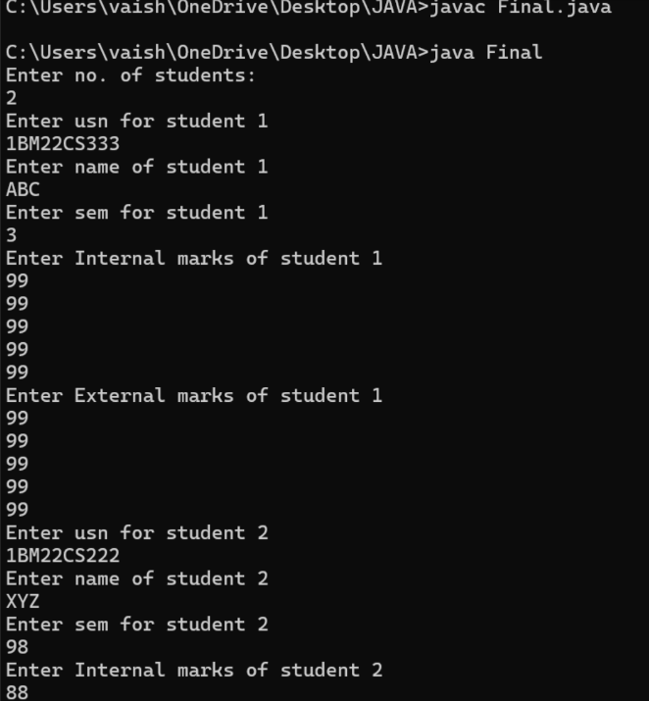

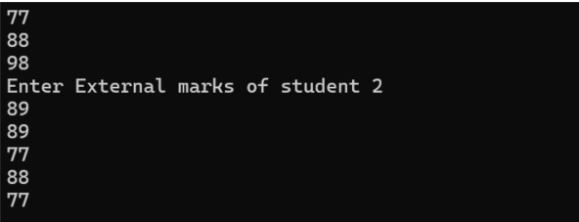

9.Write a program that demonstrates handling of exceptions in inheritance tree. Create a base class called “Father” and derived class called “Son” which extends the base class. In Father class, implement a constructor which takes the age and throws the exception WrongAge( ) when the input age<0. In Son class, implement a constructor that cases both father and son’s age and throws an exception if son’s age is >=father’s age.

import java.util.Scanner;

class Father

{

int age;

public Father(int age)

{

if (age < 0)

{throw new IllegalArgumentException("Age cannot be negative");}

this.age=age;

}

}

class Son extends Father

{

int sonage;

public Son(int age,int sonage)

{super(age);

if(sonage>=age)

{throw new IllegalArgumentException("Son's age Cannot be greater than or equal to Father's age");}

this.sonage=sonage;

}

}

public class Exception

{

public static void main(String args[])

{

Scanner s=new Scanner(System.in);

try{

System.out.println("Enter Father's Age:");

int age=s.nextInt();

System.out.println("Enter Son's Age:");

int sonage=s.nextInt();

Son sn=new Son(age,sonage);

System.out.println("Father's Age:"+sn.age);

System.out.println("Son's Age:"+sn.sonage);

}

catch(IllegalArgumentException e)

{System.out.println("Exception Caught "+e.getMessage());}

s.close();

}

}

OUTPUT:

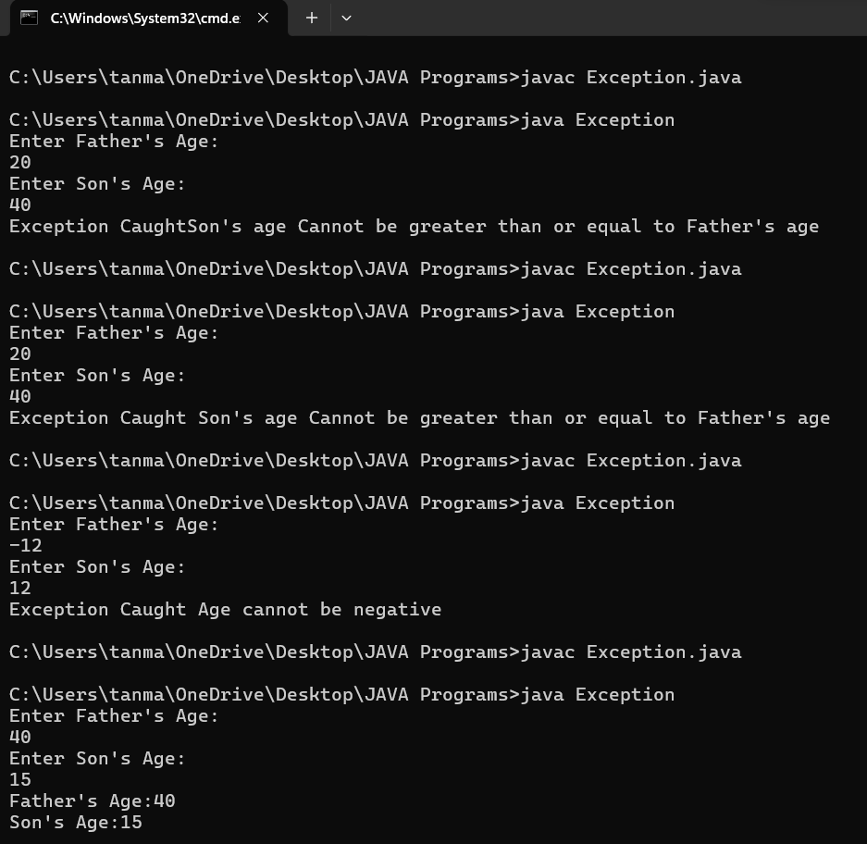

10.Write a program which creates two threads, one thread displaying “BMS College of Engineering” once every ten seconds and another displaying “CSE” once every two seconds.

class BMSCollegeThread extends Thread {

public void run() {

while (true) {

System.out.println("BMS College of Engineering");

try {

Thread.sleep(10000); // Sleep for 10 seconds

} catch (InterruptedException e) {

e.printStackTrace();

}

}

}

}

class CSEThread extends Thread {

public void run() {

while (true) {

System.out.println("CSE");

try {

Thread.sleep(2000); // Sleep for 2 seconds

} catch (InterruptedException e) {

e.printStackTrace();

}

}

}

}

class Multithread {

public static void main(String[] args) {

BMSCollegeThread bmsThread = new BMSCollegeThread();

CSEThread cseThread = new CSEThread();

bmsThread.start();

cseThread.start();

}

}

OUTPUT:

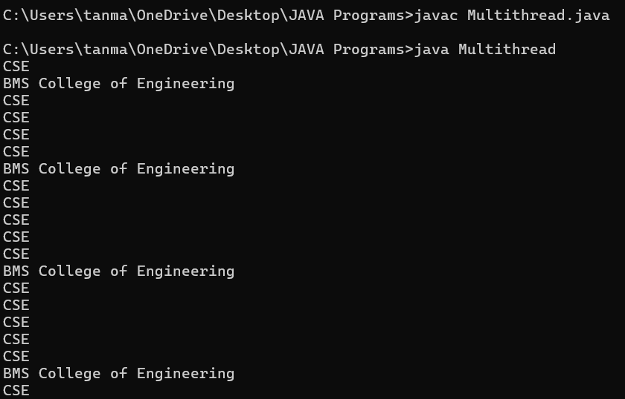

11.Creating Label,Button and TextField in a Frame using AWT.

import java.awt.*;

import java.awt.event.*;

public class AWTExample extends WindowAdapter{

Frame f;

AWTExample(){

f=new Frame();

f.addWindowListener(this);

Label l=new Label("Employee ID:");

Button b=new Button("Submit");

TextField t=new TextField();

l.setBounds(20,80,80,30);

t.setBounds(100,100,80,30);

b.setBounds(20,100,80,30);

f.add(b);

f.add(l);

f.add(t);

f.setSize(400,300);

f.setTitle("Employee Info");

f.setLayout(null);

f.setVisible(true);

}

public void windowClosing(WindowEvent e)

{

System.exit(0);

}

public static void main(String args[])

{

AWTExample awt_obj=new AWTExample();

}

}

